Testing Mock Interview - 6+ YOE (Manual + Automation) - New York based candidate

Elvina

Selenium,Cucumber,TestNG,Junit,SQL,HPALM,Agile,Waterfall

Why do you want to leave your current job?

Because I want to work in automation aleast for 50 percentage, but in my current company oppurtunities aree less and I am getting less amount of automation work.

Why automation work reduced in your company?

What is the role as a senior hybrid test engineer you are doing in your company?

What is the team size?

Manual tester

Hybrid tester

Automation tester

Dev

What all are the scenarios you will automate when you have manual test cases?

Is 100 percentage automation is possible?

What all are the testcases you should not automate?

Howmany testcases you have in your application?

Howmuch time does it require to run the whole testcases of your application?

How frequently you are running your testcases?

What is the passing percentage of your whole testcases?

What could be the reason for the failure testcases in your automation regression run? Is it because of application issue or script issue?

What is the reason for the script failure when application doesn’t have any issues?

Will get issue sometimes because of the chain is breaking with other funcationality change

Basic architecture of your framework,components and testcases other stuffs related to your framework?

What is the advantage of using page object model?

Where you will write assertions whether in page class or in someother class?

Why you are including assertion class in page class? What is the good practice for assertion class?

What is the disadvantage of page object model?

Single responsibility principle? (one of the design pattern principles)

Can we achieve parallel execution using singleton pattern?

What is souce lab?

What does mean by singleton pattern?

What is the connection between souce lab and remote webdriver?

How you are running your testcases on soucelab?

Desired capabilities?

Selenium Grid?

What is the concept of Grid?

What is the best practice to design a feature file? When we have to use then,given,and,when,background, scenario outline?

What is the difference between hooks and background?

Where do we specify hooks? Inside class file or inside feature file?

What is the difference between data table and examples?

Whose responsibility is this is to write feature file?

Do share your feature file with developer and share holders and PO?

How comfortable you are in selenium?

Why do you get stale element exception?

Tell me the difference between implicit wait and explicit wait?

<https://lms.simplilearn.com/courses/2823/GIT/syllabus>

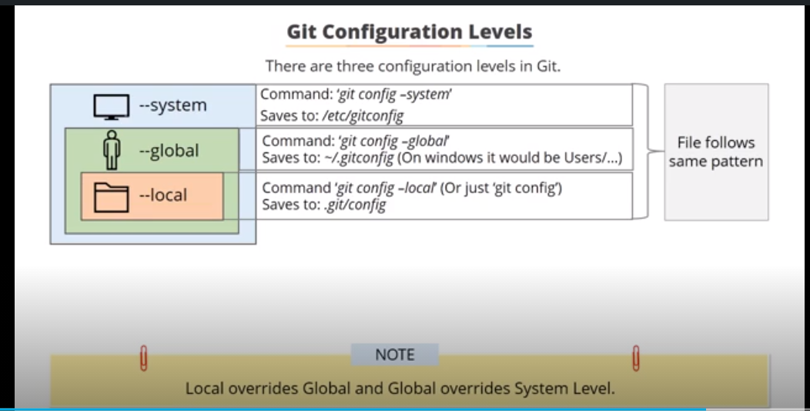

git commit -m "initial version"

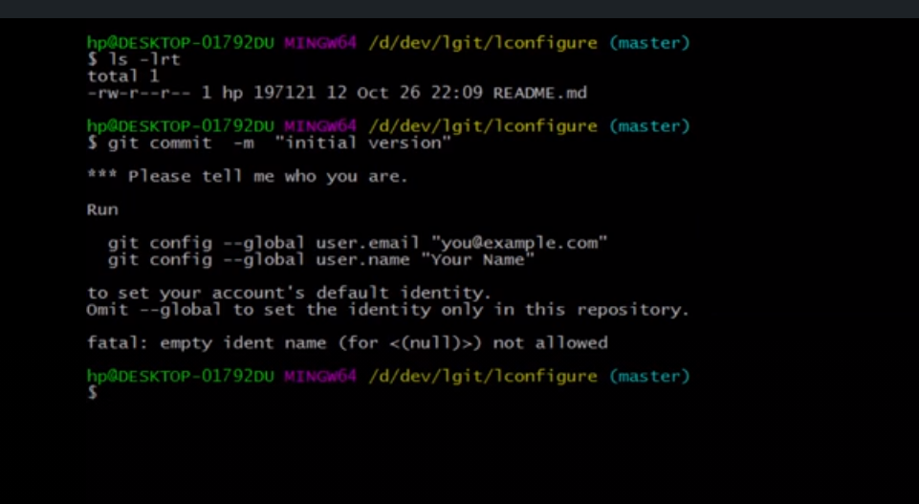

git config --global user.name "surendarg97"

git config --global user.email "surendarg97@gmail.com"

git config –list

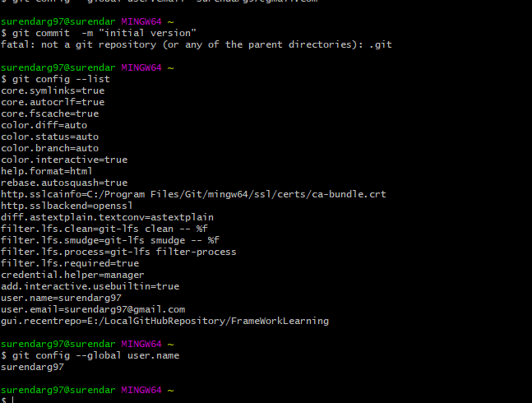

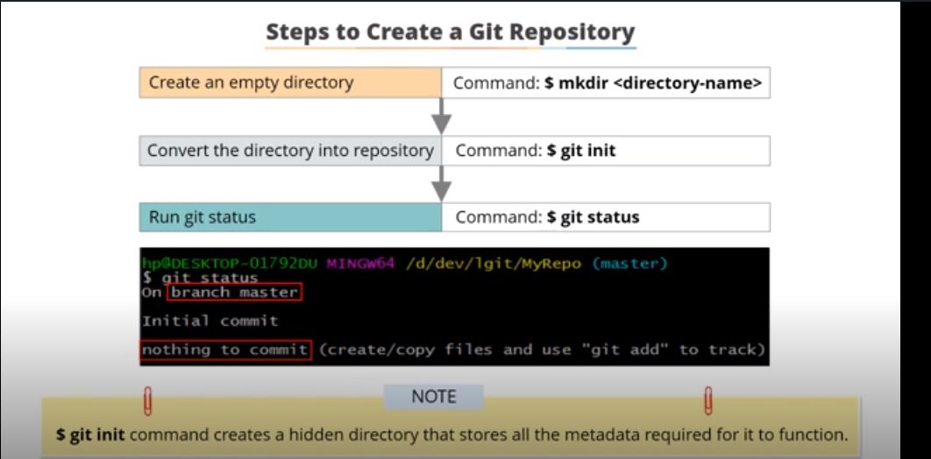

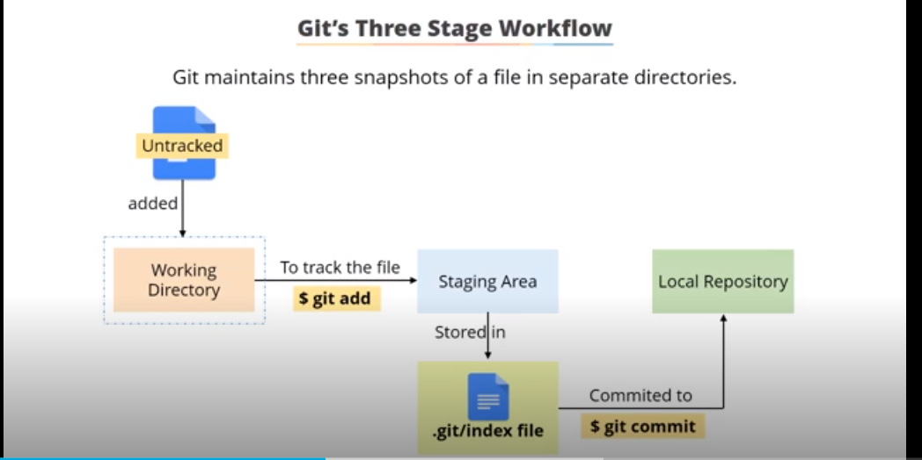

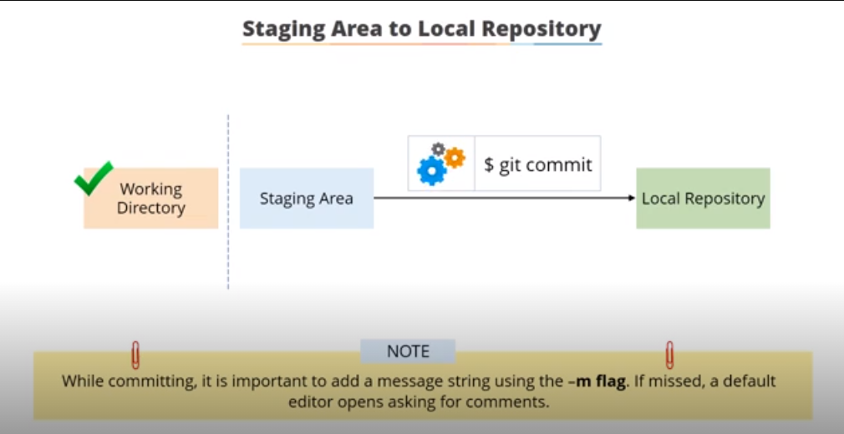

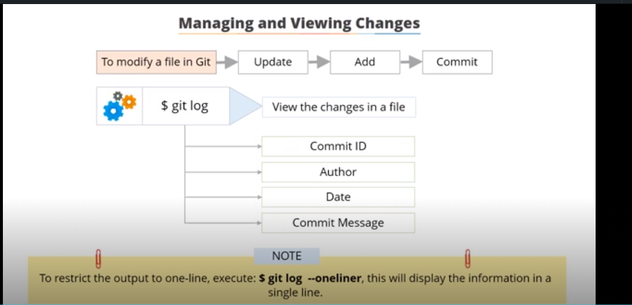

git log –oneline

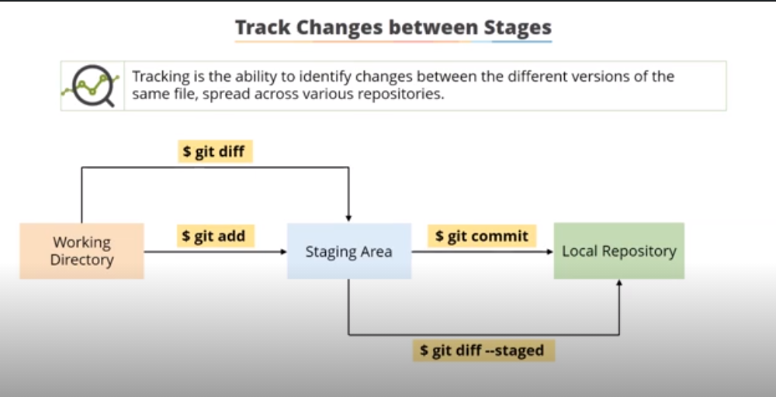

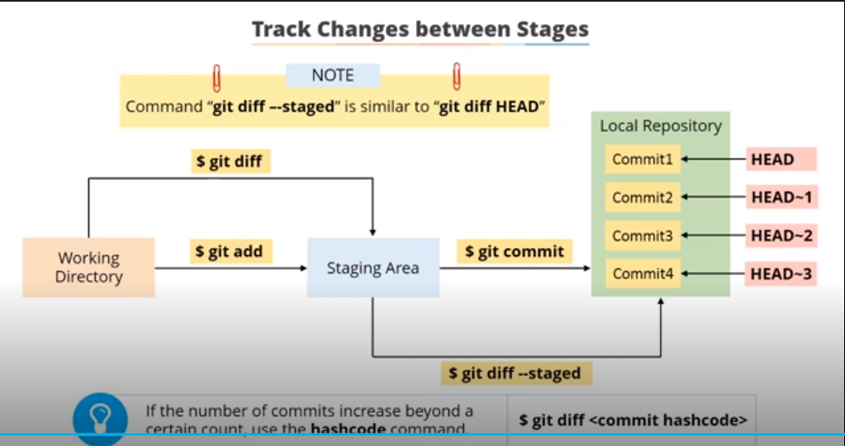

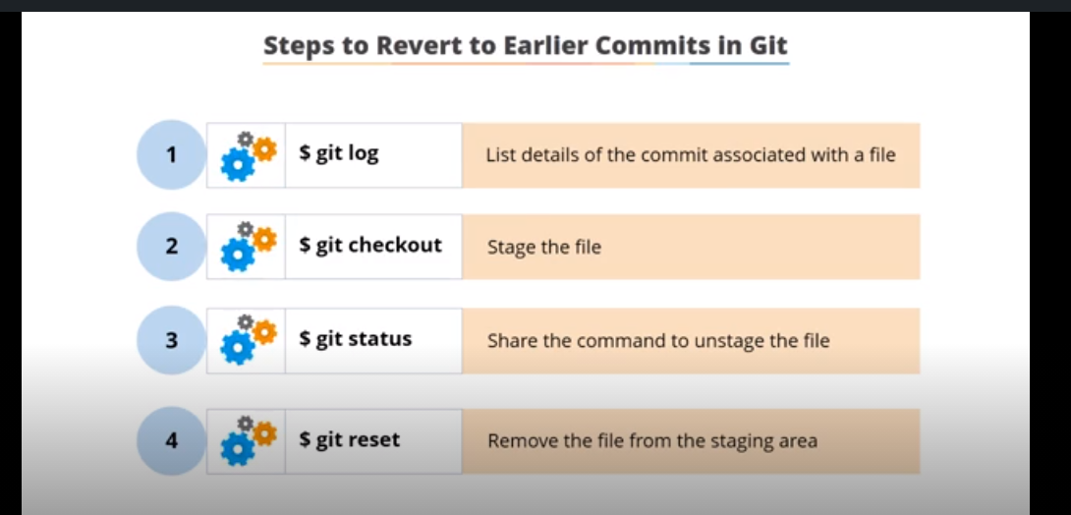

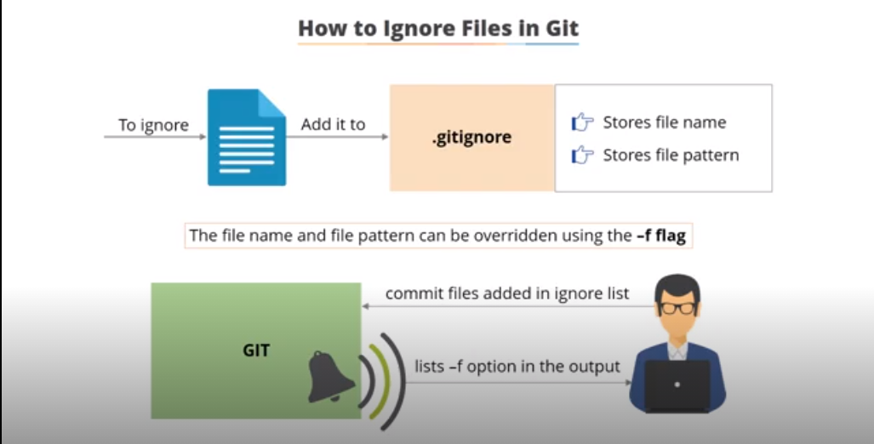

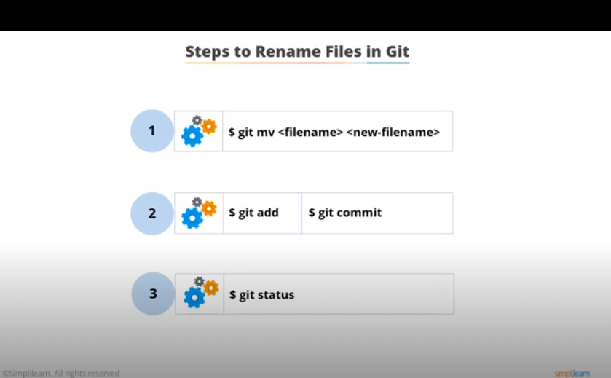

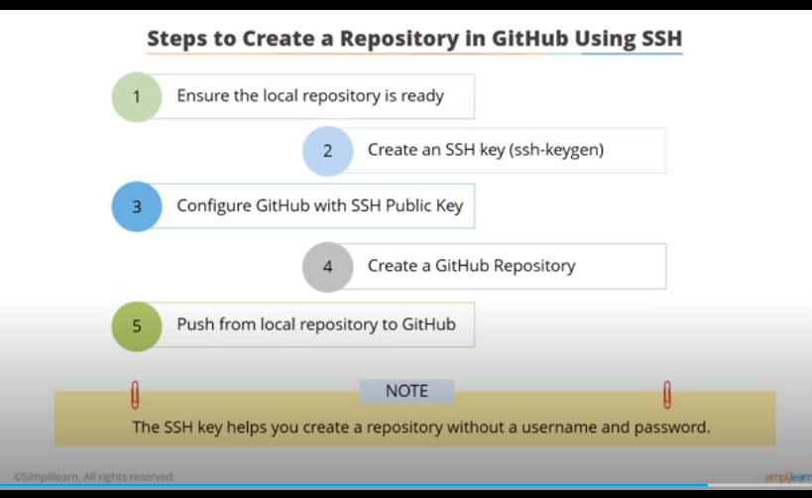

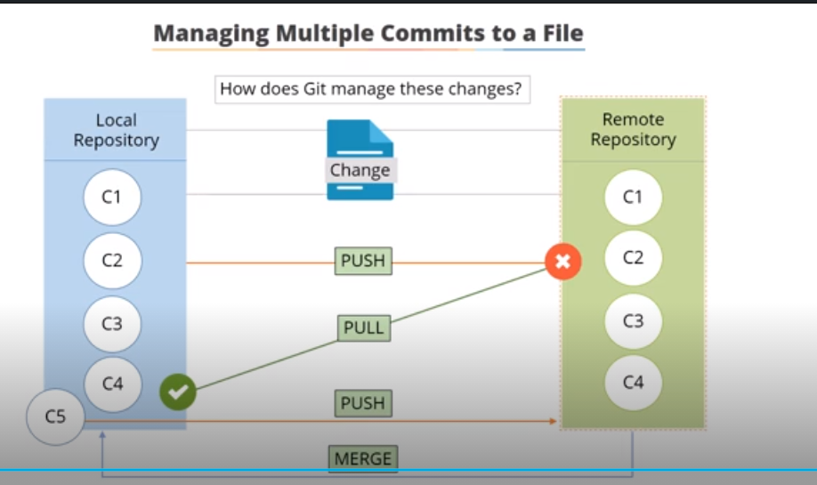

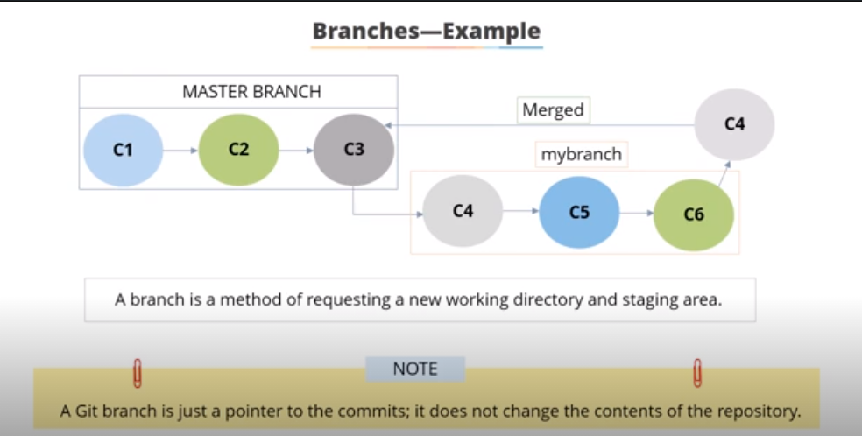

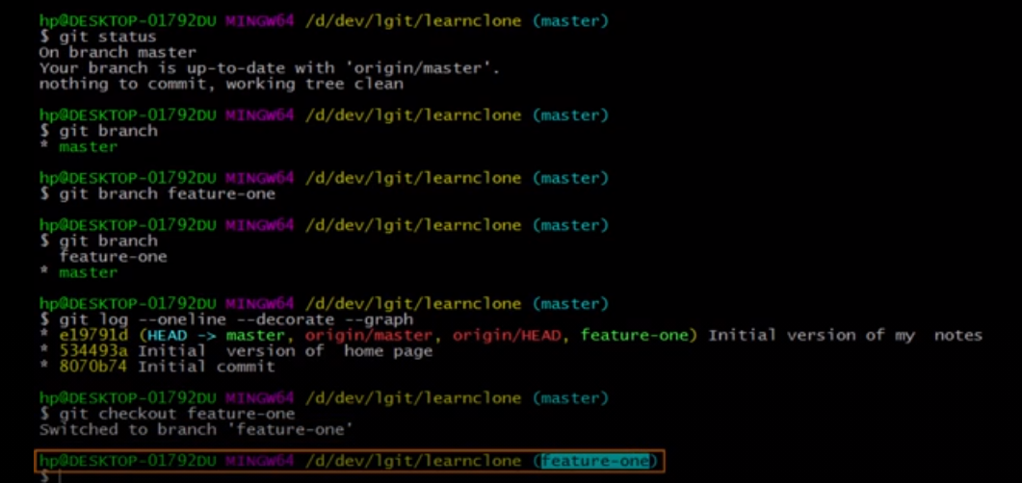

Javascript executor

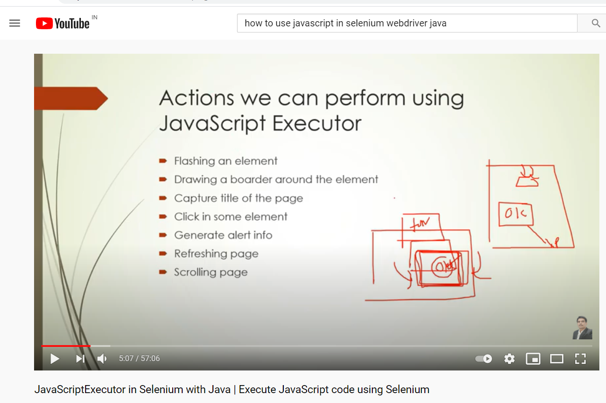

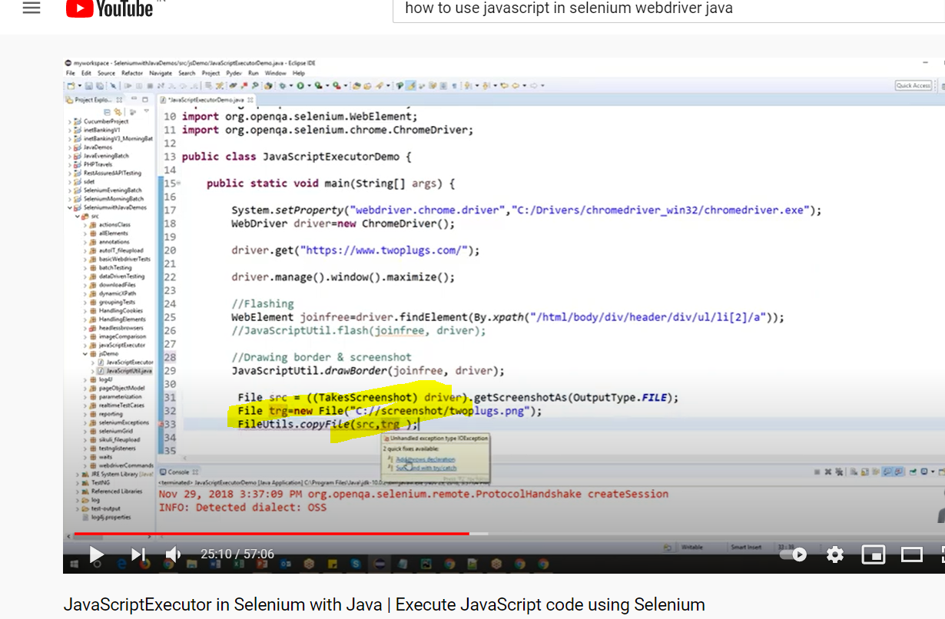

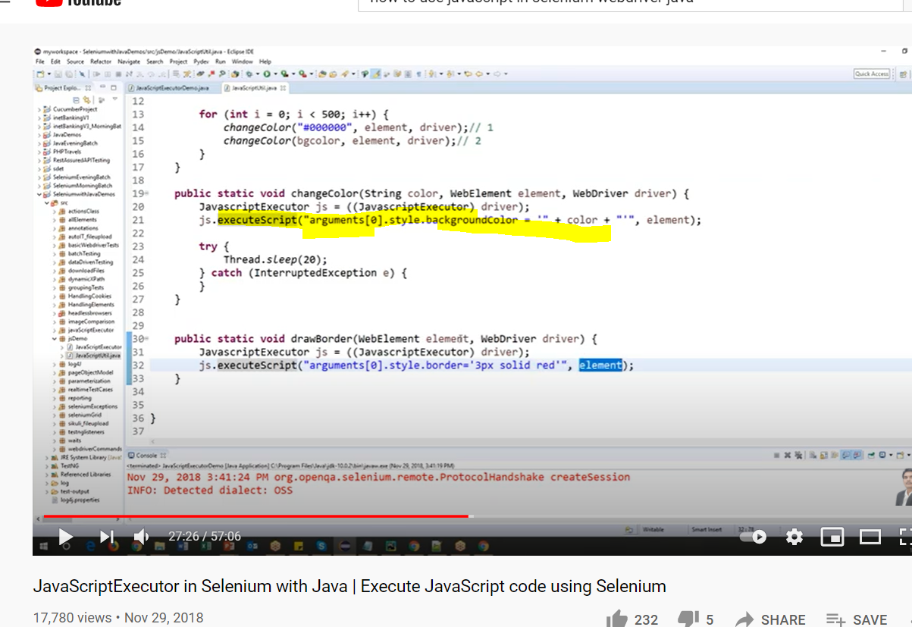

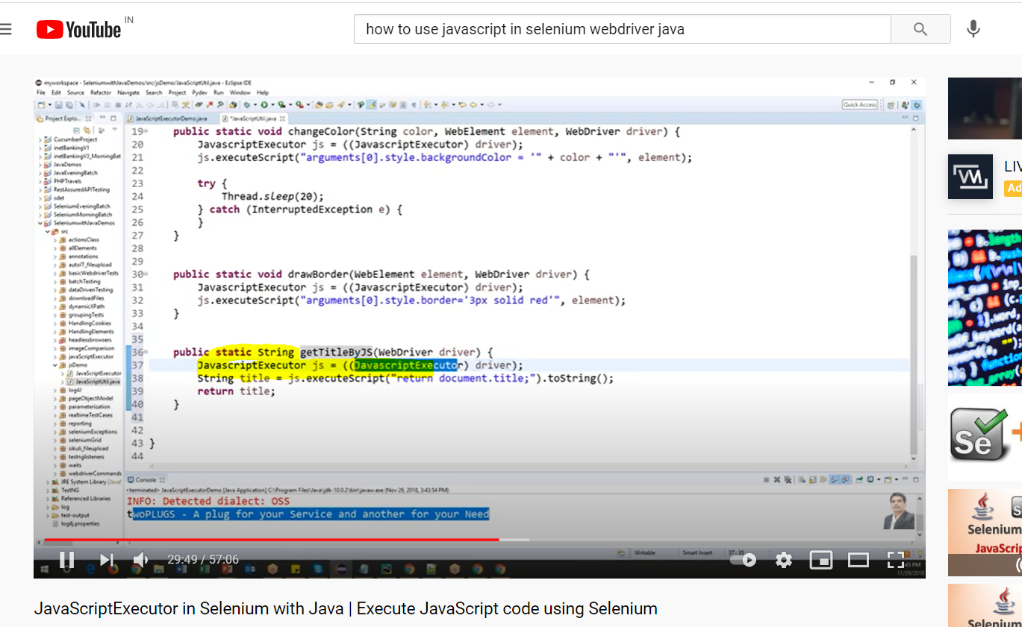

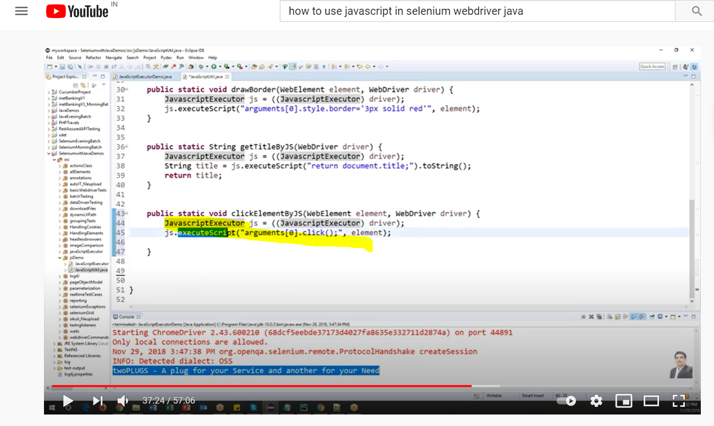

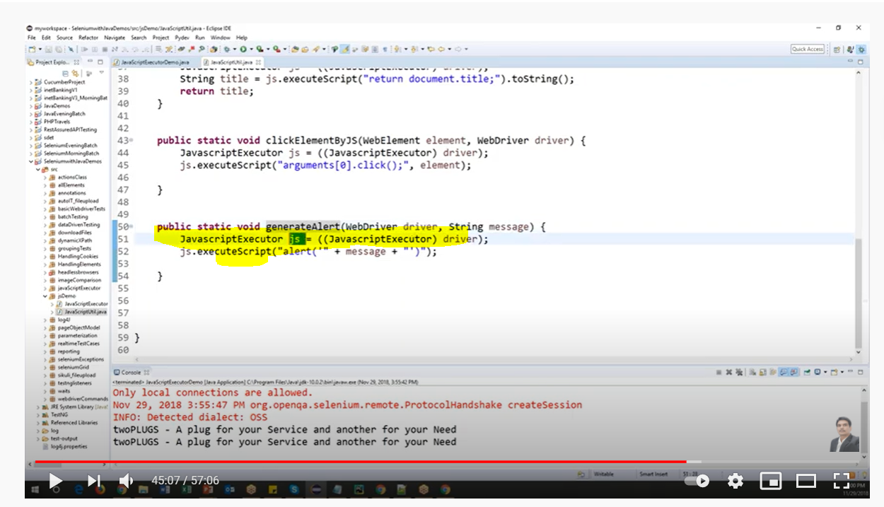

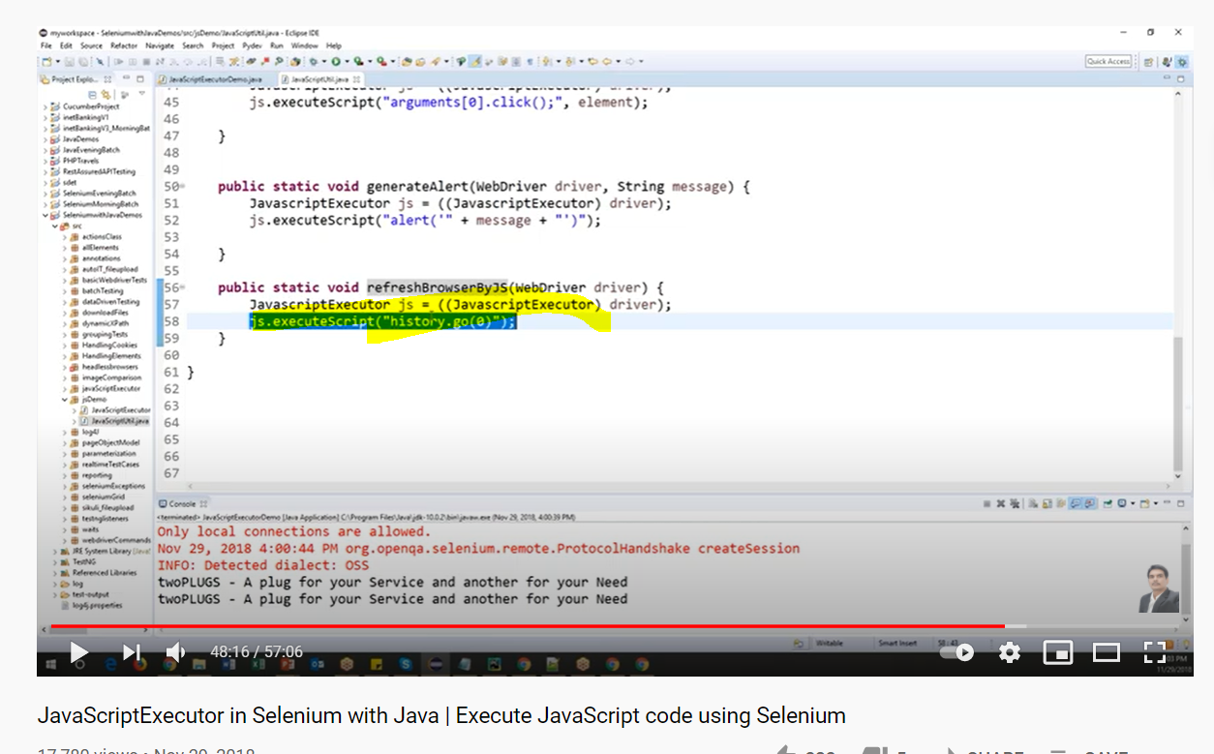

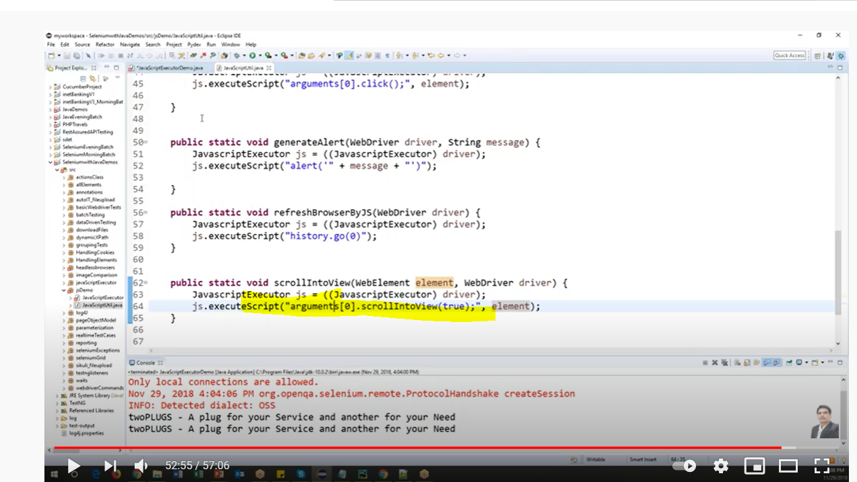

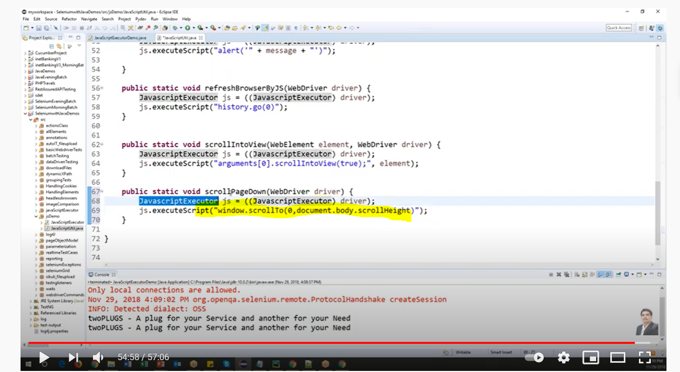

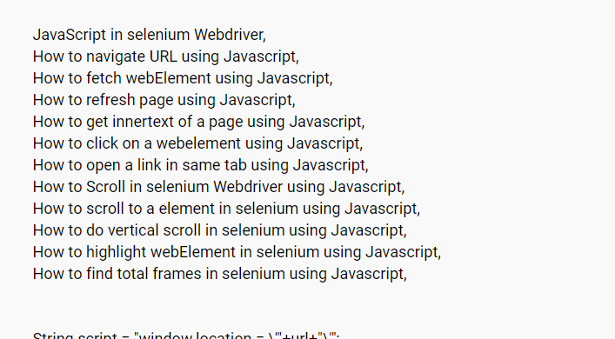

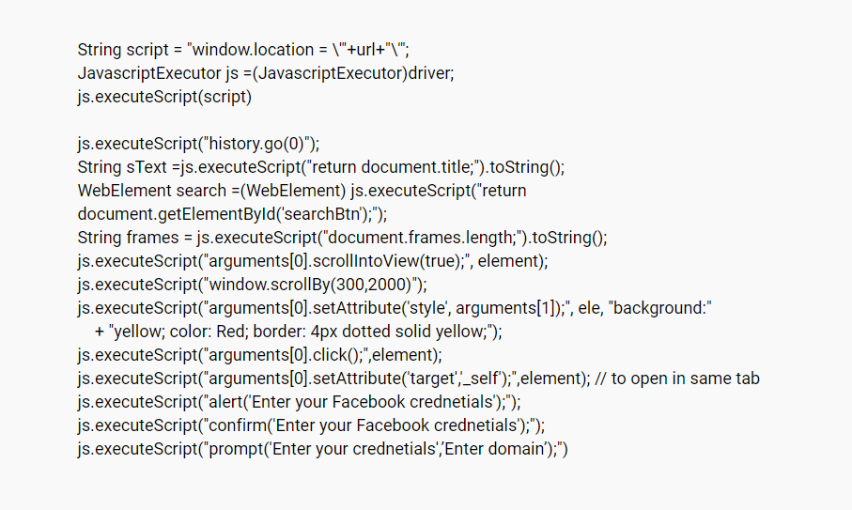

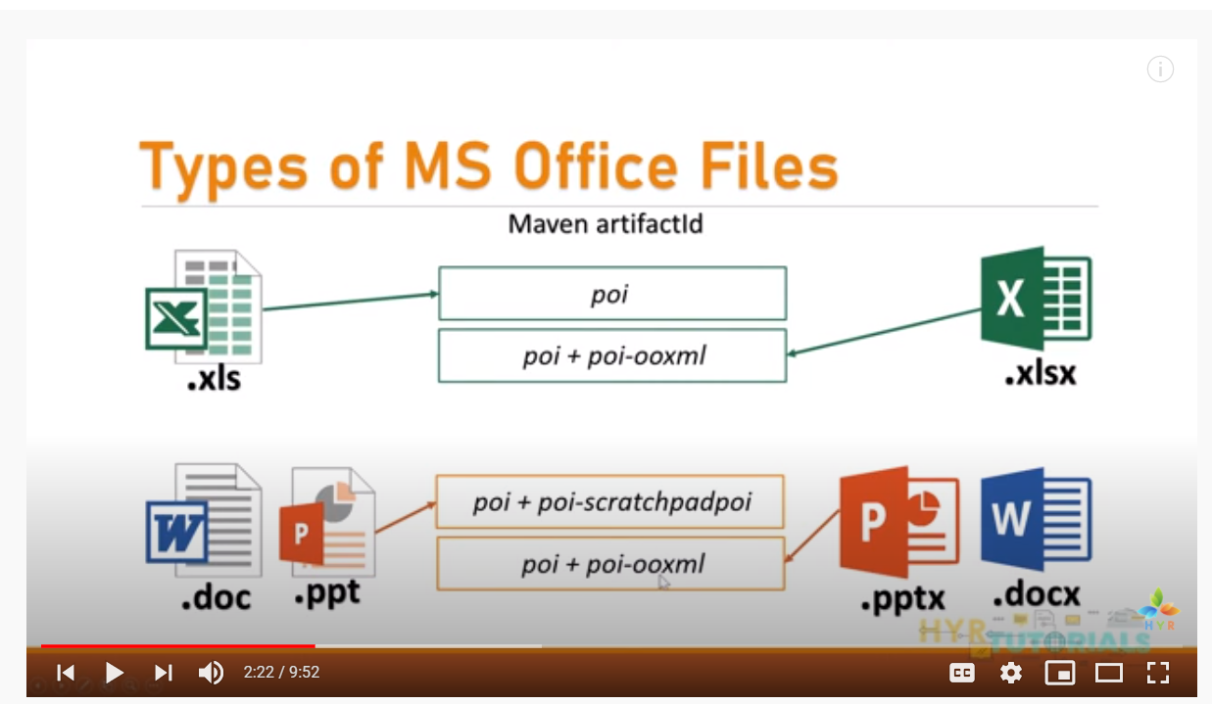

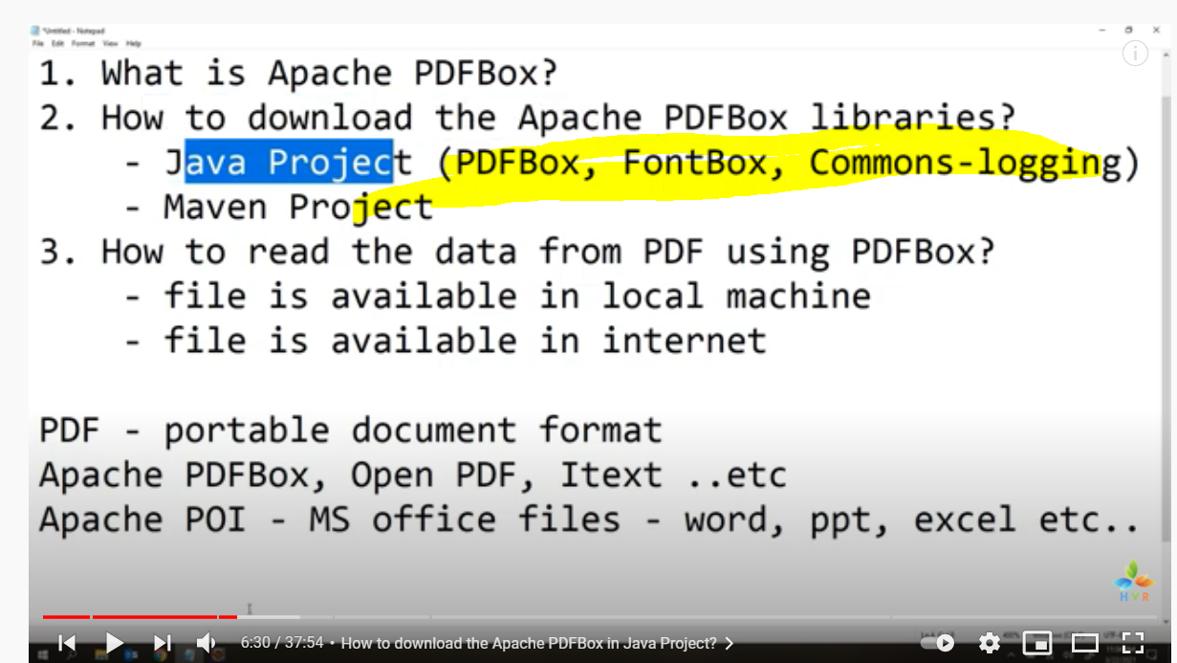

<http://www.aosabook.org/en/selenium.html>

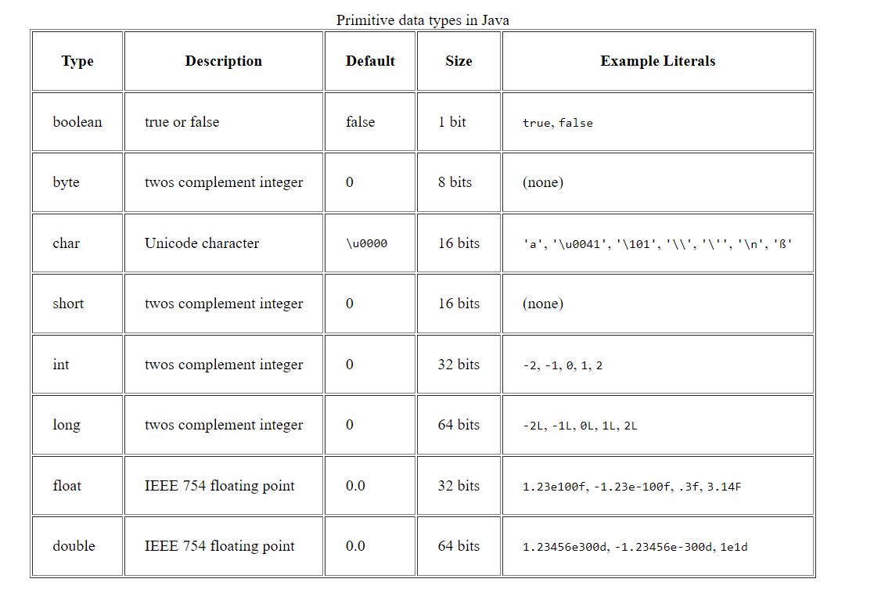

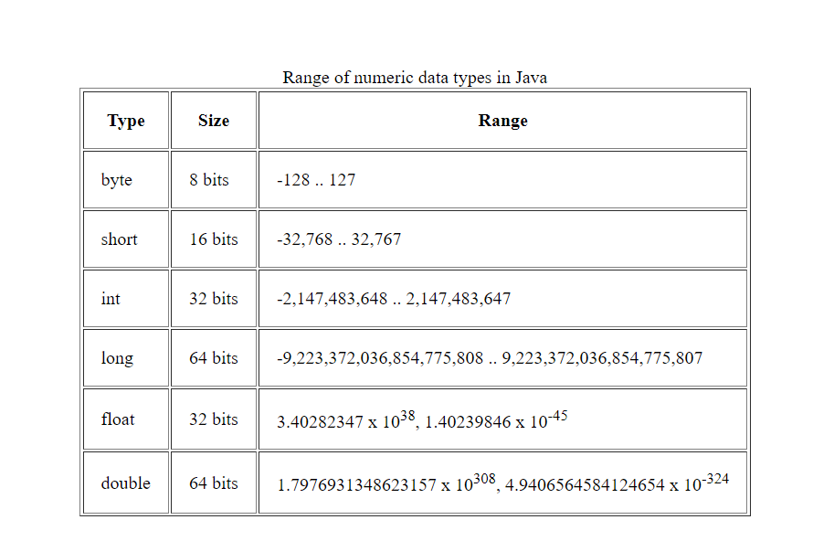

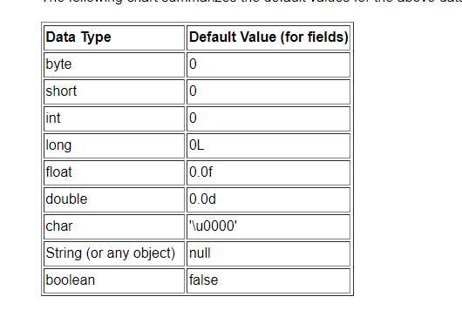

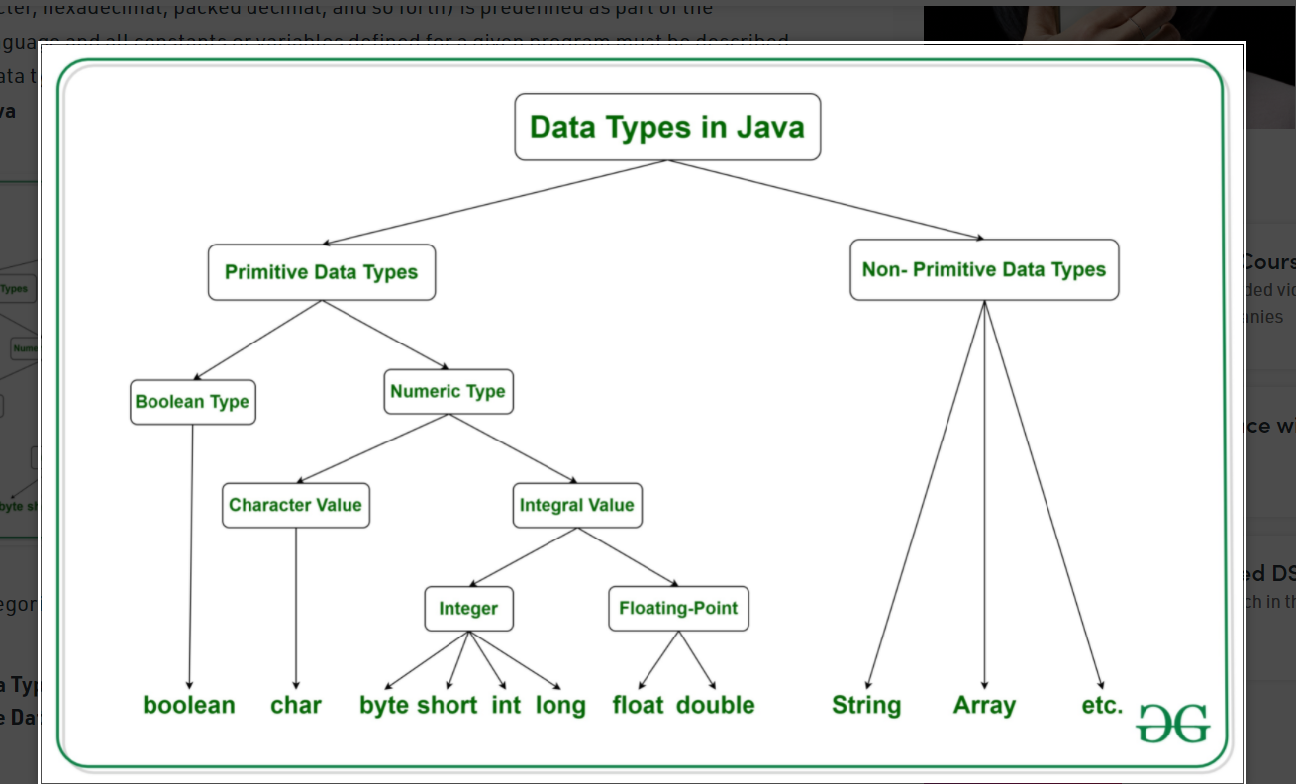

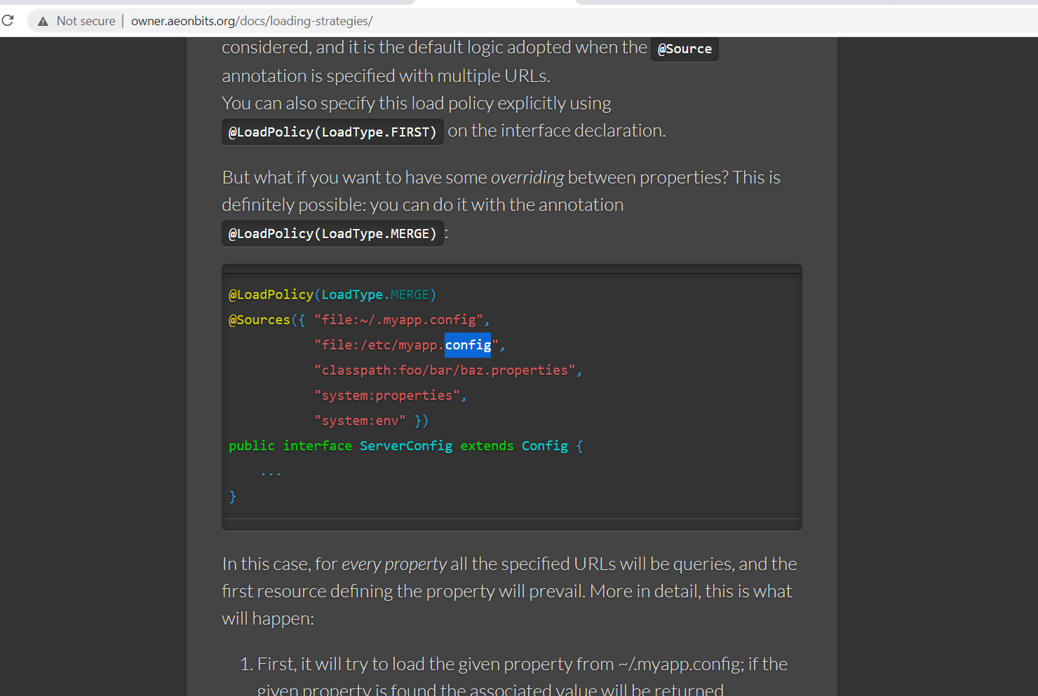

Can you brief about yourself and what is your roles and responsibilities?

Hi xxx. I am surendar. Currently Im working as senior software tester engineer in wipro technologies ~~branch located in Chennai~~. Have overall 5 years’ experience in testing domain and that too with US mortgage home loan application which is comes under banking industry.

Coming to my roles and responsibilities, ill participate in all the testing activities from manual as well as automation. Coming to Manual ill involve in Test Case requirement analysis, Test Case design and planning, Test case execution and Test result preparation. When it comes to Automation ill involve in Regression suite analysis for the new enhancement, then ill work with manual tester for Automation required test cases for that specific functionality, then automation script writing and execution.

My application is related to web application and we are using selenium webdriver as a automation tool with using java language.

Questions:

What is the total number of testcases we have in our application and howmuch percentage we have covered in automation?

Mobile automation?

API Automation?

Performance testing?

Security testing?

What is the difference between hashmap and hashtable?

Both HashMap and Hashtable implements Map interface but there is some significant difference between them which is important to remember before deciding whether to use HashMap or Hashtable in Java. Some of them are thread-safety, synchronization, and speed

Java Programs

https://www.youtube.com/watch?v=481wo2W0Hwo&list=PLMxpKvJf0K0QV8YSVDQJ85xN3NA9cqM0o&index=2

Count of words

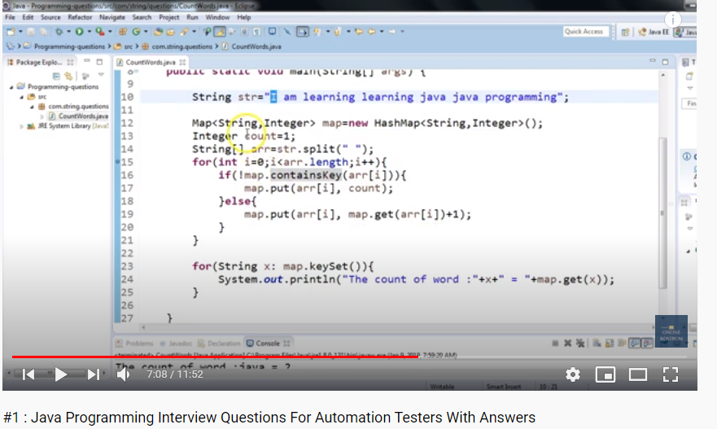

Count of character occurrences

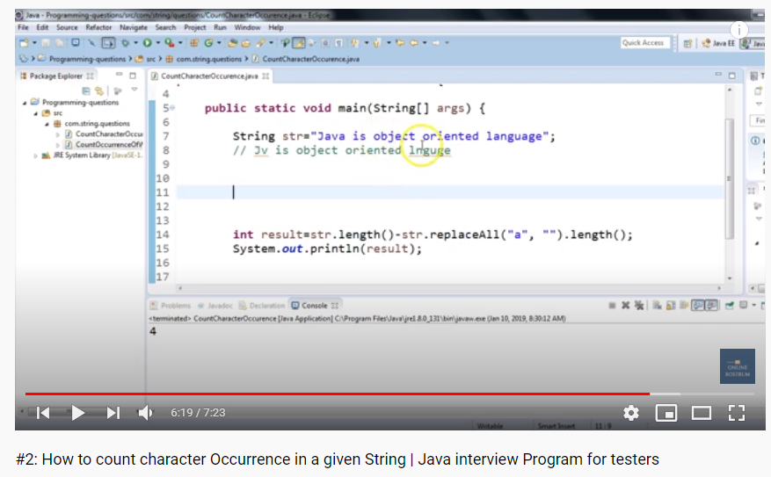

Count of duplicate characters

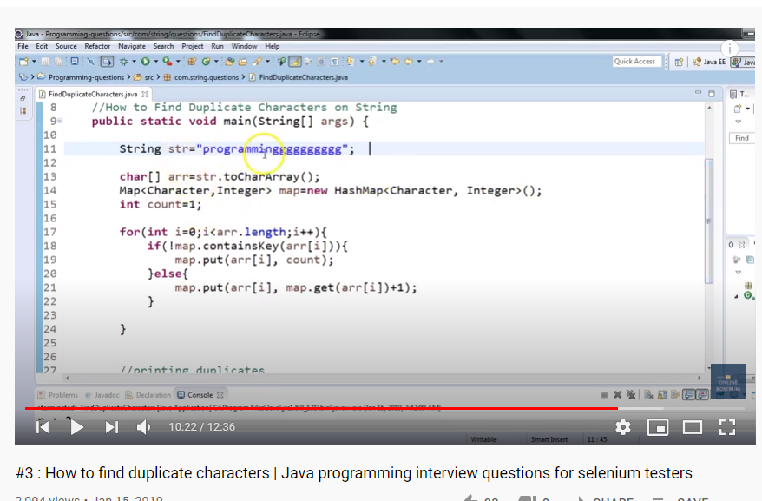

Strings is anagram or not

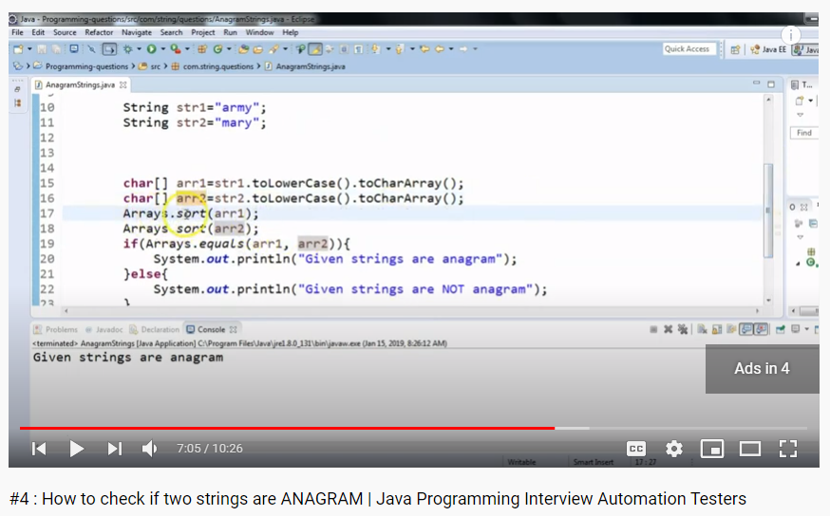

First non repeated character in the given String

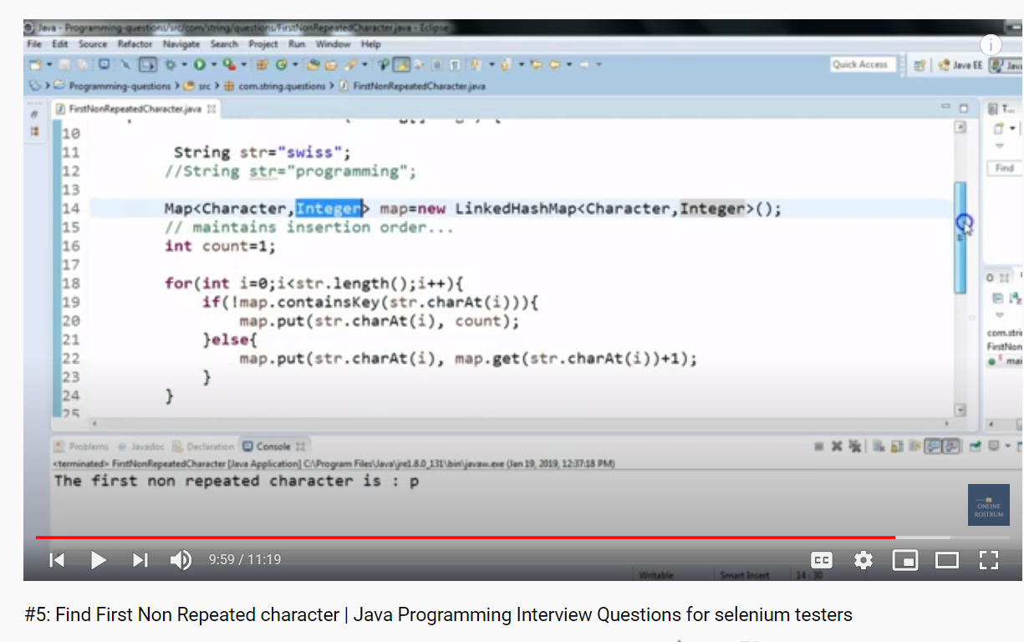

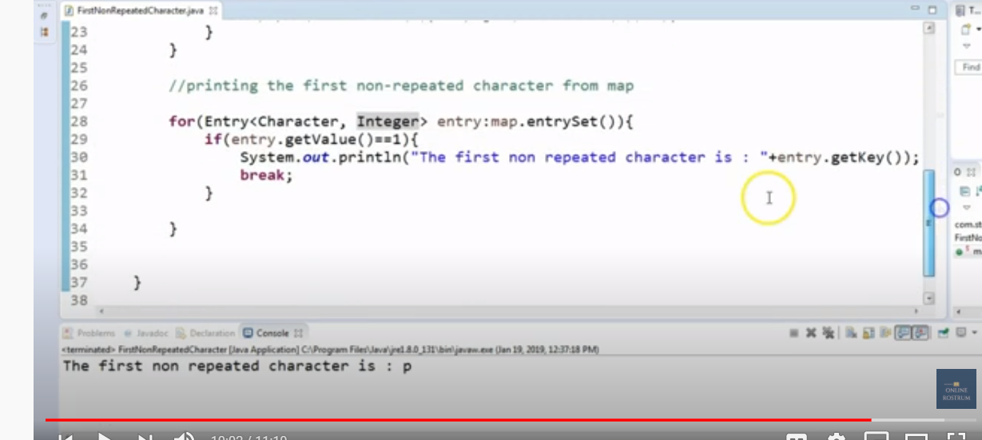

Amdocs Interview Question| Test Case Interview| Amdocs Testing Interview Questions| amdocs

<https://www.youtube.com/watch?v=ZTXBWl7Jv3c>

• What is gray box testing?

In white box testing tester or developer knowing the internal structure of item, like codes and their algorithms. But in blockbox testing tester will not know the internal structure of item going to be tested.

So here gray box testing is the combination of both black and whitebox testing, so partially tester will know the internal structure of item going to be tested.

• What is the objective of gray box testing?

To provide the combined advantage of black and white box testing

IT will give time to developer to fix the defect

It will be tested from the view of endpoint user rather than developer point of view

To imporove the overall productivity quality

It will minimize the separate effort required for functional and non functional testing

To combine the input of tester as well as developer

• Write test cases of anything?

• what is GIT?

Git is a version control system. It used to maintain the Code in a central distributed repository.

So any modification in the code will be always tracked and if required it can be rolled back. And it

maintains the version. So it can be reverted to any version.

Git commands

* Git init - it would create empty local git repository in a specified directory
* Git clone – It is used to clone the repository copy to your local machine
* Git config user.name <name> - authentication to access git repository
* Git add <directory> - it will stage all the changes in the files in the directory for the next commit
* Git commit –m <message> - Commit the staged changes with the message
* Git status – List which files are staged,unstaged and untracked
* Git log – Dispalys the entire commit history in the default format
* Git diff – it will show the ustaged changed between your working directory and staged changes